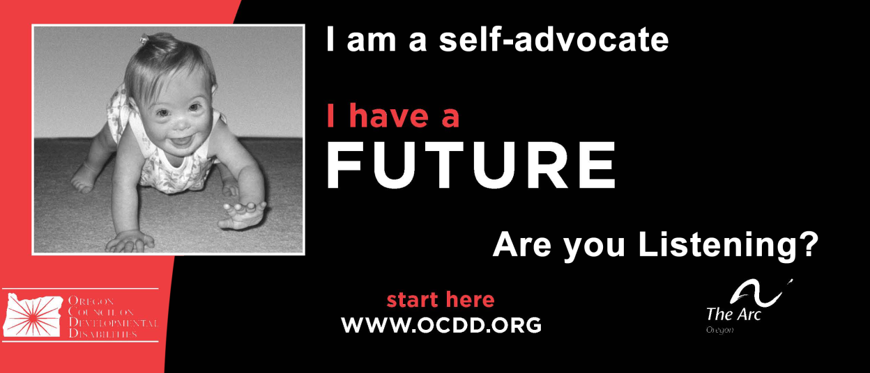

|  |  |
| --- | --- |
| What’s New for Teachers/Case Managers? …………………………………………….. | 1 |
| Clarification Regarding Federal Financial Aid 008 2013-14 …………………………… | 3 |
| Frequently Asked Questions for Oregon Diploma Options ……………………………. | 4 |
| Transition Technical Assistance Network ……………………………………………….. | 17 |
| Transition Planning Checklist for IEP Teams …………………………………………… | 21 |
| Purpose of Universal Design for Learning Curriculum …………………………………. | 22 |
| Universal Design for Learning Guidelines ……………………………………………….. | 23 |
| Guide to Common Core State Standards ……………………………………………….. | 24 |
| What is Smarter Balanced? ………………………………………………………………. | 26 |
| Accommodations for Students with Disabilities ………………………………………… | 28 |
| Functional Limitation Statement, Impediment to Employment ………………………… | 29 |
| Templates: IEP Discussion Starters …………………………………………………….. | 31 |
| How Do I Complete the Summary of Performance? …………………………………… | 34 |
| Examples of Completed Summary of Performance Documents ……………………… | 37 |
| Person Centered Planning Introduction ………………………………………………… | 39 |
| Person Centered Planning Facilitators …………………………………………………... | 40 |
| Person Centered Planning Examples ……………………………………………………. | 42 |
| Person Centered Planning Form …………………………………………………………. | 45 |
| Template --Transition-Age Youth –County Agency Overview ………………………… | 46 |
| Indicator 13: Transition Standards Performance ……………………………………….. | 47 |
| Indicator 14: Post School Outcomes Oregon – who …………………………………... | 48 |
| Contacting Hard –to-Find Youth: Strategies for the Post School Survey ……………. | 49 |
| Indicator 14: Post School Outcomes Performance ……………………………………. | 51 |
| Post School Outcomes Statewide Data Report 2013 ………………………………….. | 53 |

Table of Contents--- **Teachers Section**