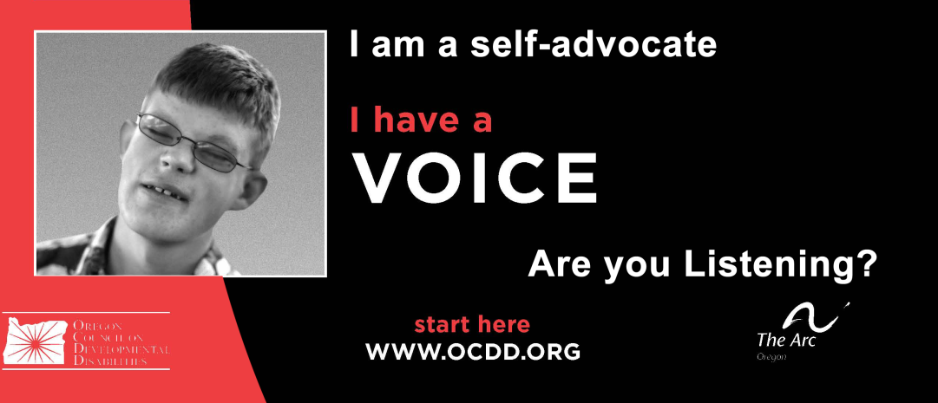

|  |  |
| --- | --- |
| Transition Planning: Setting Lifelong Goals……………………………….. | 1 |
| Common Core FAQ …………………………………………………………. | 3 |
| Transition Community Network……………………………………………... | 5 |
| Understanding Common Core Standards Brochure……………………… | 7 |
| Plan for Work, Disability Rights Oregon Brochure……………………….. | 9 |
| FACT Family and Community Together Brochure………………………... | 11 |
| FACT Family and Community Together _Spanish Brochure …………… | 13 |
| Vocational Rehabilitation – Your Partner to Employment Brochure…….. | 15 |
| Vocational Rehabilitation – Focus on Employment Brochure…………… | 17 |
| Vocational Rehabilitation -- Spanish Focus on Employment Brochure… | 19 |
| Employment First Brochure ………………………………………………… | 21 |

Table of Contents --- **Families Section**