Special Education Post School Outcomes Application 2.0
The PSO 2.0 Application is to be used for all Post School Outcomes data entry and viewing reports
- 2014 Exit Interviews can be entered March through September.
- The list of students to interview for the 2014 Follow Up Interviews will be posted in early April. Data can be entered June 1 through September.
Landing page: Welcome to the PSO Web Application 2.0
We need to know who to contact for notifications and questions. Please enter contact information in the gray boxes at the bottom of the page – you can specify different people for the Exit and the Follow up contacts, interviewers, and transition teachers or specialists in your district. This list will be used to notify district personnel of trainings, or updates on the PSO collection.

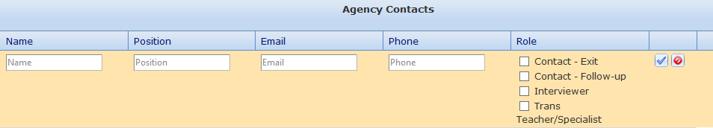

Data Entry and Reporting
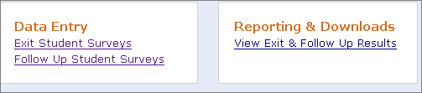
- Select which collection you want to enter by clicking one of the links in the Data Entry option.
- The Reporting & Download option takes you to Excel data downloads and reports.
- The ODE Resources tab at the top of the page contains Exit and Follow Up forms and materials.
Data Entry: Exit Interview: Student List
- Districts need to enter students that leave SE services during the school year, this cannot be pre-populated.
- Click Add New Student, and enter the SSID number and the Find button. Data on student should appear.
- Click Confirm to enter the student, their name will appear in your list, and can be clicked to enter interview.
- Information is saved when you move down to the next question. Click Submit Final when done. (You can return to edit the information by selecting Unlock Survey from the blue Action box at the end of the row.)
- When you have completed all data entry for the Exit collection, check the Yes button in the peach ‘Collection Complete’ box.
- If the SSID number does not work to access a student, contact Pattie Johnson at johnsop@wou.edu as the student may be in the system for another district.
Data Entry: Follow up Interview: Student List
- Districts are provided with a list of all students who were reported as exited on the SE exit collection and did not return to be included in the following year SECC.
- Students have a Priority Code designating whether they are Required, serve as an Alternate, or have not been selected but could be interviewed.
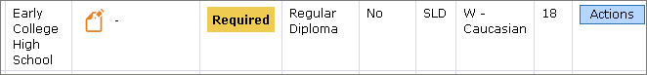
- Call logs are available which include contact information for the student, and tracking for interview attempts. Click blue Actions box to print a call log, print a survey, or unlock a record if it has been submitted as ‘final’
- You can print a collection of call logs by checking the box before the name and Downloading Call Log PDF’s from the option above the student list header. You can also download a copy of your data in Excel.
- Click on student name to open the follow up interview form for data entry.
- The survey questions will not open unless you have selected Completed or in process for the 1st question
- Information is saved when you move down to the next question. Click Submit Final when finished.
- When you have completed all data entry for the Follow up collection, check the Yes button in the peach ‘Collection Complete’ box. Notification will be sent to ODE, and you are done.
Follow up interview data notes:
- Skip patterns are built into the follow up interview form: some follow up questions will only appear after a 'yes' answer has been entered in a question.
- Questions marked with an “*” are required for federal reporting.
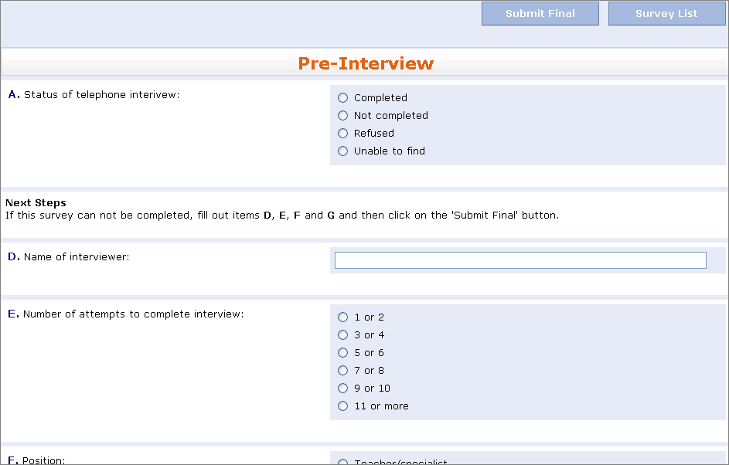
- The Pre-interview information is on the top of the call log
- To exit after starting an interview, but before you are ready to submit final, use the Survey List button. DO NOT use the back button or the Home selection from the top bar or data may be lost
- A survey is considered completed when no additional efforts can be made to gain more information: data entered, client refused, or district unable to find the student despite making multiple attempts, preferably at different times of day or weekend.
- Completed or in-process interviews include forms still in process such as appointment made to complete interview.

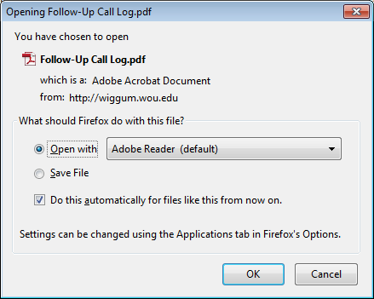
Download Call Log PDF
- To print the call log(s) select as many students as needed (check boxes in front of name)
- Use “Download Call Log PDF” to get PDF file of all selected students. This will open a window, see below (Firefox was used to open this window; it may look different using a different internet explorer).
- If additional call logs are needed later: un-select the check boxes of the students whose call logs have already been printed and select the next student or group of students
- An example of the call log is shown here; the downloaded version contains student’s information.

Other things to know
- Interviews conducted during the summer or fall should only include work or school in the 12 months after leaving school
- Students who appear on your district list as “required” need to be contacted for the follow-up survey, even if they did not participate in the Exit interview last year. Use district discretion if there are individuals that shouldn’t be contacted, but leave a note in the Question G text box explaining the situation.
- Question A – Status of interview is used to show the completion rate in the white box on the Data Entry page.
  - Completed or in process = all required questions are answered or you are ready to do online interview
  - Not completed = made contact with student/family (i.e. phone number worked, left message, started but did not complete interview, person set time to call back for interview, but never able to reach again, etc. )
  - Refused = family or student contacted, but did not choose to complete interview (make note in Question G text box describing situation)
  - Unable to find = all alternatives for finding the student or family failed (phone, emergency contacts while in school, social media, etc.)
- Please do not enter hard returns in text box comments, they all have to be manually removed later

If you have questions, please contact Pattie Johnson: johnsop@wou.edu

