**Example of Person Centered Plan: Allison**

**GOAL!!!**

***Graduate from East End High School; attend Eastern Oregon University in Child Development. After graduation from EOU become an early childhood education teacher in Pendleton School district***

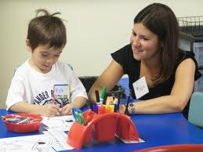

**Work in Pendleton School District**

**Continue Learning!**

* Enroll at Eastern Oregon University
* Get disability services from EOU for assistance in note-taking and study partners.



**Graduate from High School**

* Work on organizational skills
* Job shadow experiences with children
* Be aware of the accommodations I need for reading

**Allison’s Plan for her future:**

--Develop my organizational skills -- Visit Eastern Oregon University

--Graduate from High School -- Find out more about working with children

--Plan the classes I need to graduate from -- Explore teaching in the Pendleton area

EOU in Child Development



**Example Person Centered Plan: Alex**

**GOAL!!!**

Alex is graduated, employed and ready to live independently in the community.





**Graduate from South Eugene High School**

* Practice Reading
* Take more math classes

**Continue Learning!**

* Enroll in ITT Technical Institute
* Study business



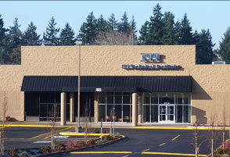

**Alex’s Transition Plan:**

1. Practice Reading
2. Work at Home Depot part time
3. Talk to Springfield OVRS about communicating better
4. Graduate from South Eugene High School
5. Go to ITT Technical School

**Enroll in Springfield OVRS**

* Develop better communication skills!

**Work at OFFICE DEPOT**

* Work part time –10 hrs per wk until I graduate
* After graduation work 20 hours per week

