Indicator 14 Post School Outcomes Oregon – Who Makes the Call
- Follow Up interview calls made by Teachers, Administrators, and YTP were more likely to result in complete interviews!

- Calls made by Paraprofessionals, Assistants, and clerical staff were less likely to result in completed interviews.

- Oregon information: PSO follow up interviews

- 42% of completed calls were done by teachers or administrators
- 22% by clerical staff
- 18% by YTP personnel
- 16% by Paraprofessionals/Ed Assistants

Adaptation of National Post School Outcomes Document on Contacting Hard to Find Youth: Strategies for the Post-School Interviews

- Provide Pre-Notification
  - In school, discuss the interview with students before they leave
  - Share what district has learned from past students
  - Include PSO information with other information in end of school packets
  - Have students identify who should call them during last IEP meeting (teacher, coach, etc.)
- Create Familiarity
  - Best motivator from study = help other students
  - Practice interview before starting calls
- Show Interest When Conducting the Survey
  - Be enthusiastic and interested in the answers
  - Convey a non-judgmental tone
- Provide Incentives
  - Remind students that information will be shared to help other students and improve school services, that you want their feedback
  - Modest, $5.00 monetary incentive to “hardest” of the hard to find youth
- Maintain Contact
  - Know who in family is still in school
  - Leave call back number on messages so youth know it’s you
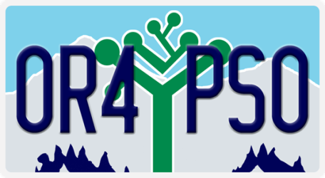
  - Use PSO logo on all materials, reminders,

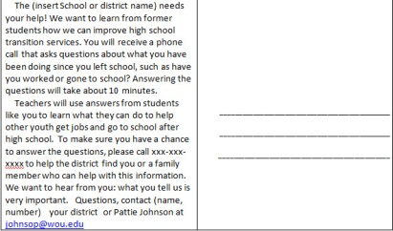
Oregon’s resources for the Post School Outcomes collection can be found on the PSO 2.0 application on the ODE Resources TAB and on the Transition Community Network District Resource page: http://tcntransition.org/resources/post-school-outcomes-materials

