Transition Community Network

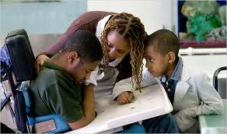
Teachers (sample)
Inclusion Resources for teachers include instructing student with High-incidence disabilities in the general education classroom, inclusion of students with low-incidence disabilities, and curriculum adaptions
OARs included are a list of the Oregon publications about special education policy and laws, and OARs new in June 2013 are also included
IEP resources include Transition IEP, Oregon Standard IEP, and understanding the transition IEP process
Directory of Services includes a list of contacts for VR and DD; it also includes links for SNAP, ARC, PCL, Oregon Health plan, and SSI
Effective Practices is organized by skill being taught
Oregon Department of Education special education information includes links to diploma options, essential skills, extended assessment, indicator 13, and staff lookup,
Helping your student plan for adult life through links to websites such as College planning, independent living connections, how to set goals, effective study strategies, planning for a job, getting a driver’s license, job corps, military.com, job accommodation network, and many others

A new website www.tcntransition.org will open September 30, 2013

