The ***STUDENT and FAMILIES*** section supports working together to support the child’s independence through the effective use of transition components. This section is most appropriate for case managers, teachers, administrators or school personnel when working with students, parents, guardians, and foster parents.

|  |  |
| --- | --- |
| Transition Planning Checklist …………………………………………. | 1 |
| Student Transition Questionnaire……………………………………… | 3 |
| Diploma Credit Requirements and Essential Skills, 2014 ………….. | 5 |
| Key Differences between High School and College ………………… | 6 |
| Post School Outcomes (PSO) Data Collection……………………….. | 9 |
| Post Card Notification of Post School Outcome Data Collection…… | 10 |
| PSO Follow Up Interview: Example……………………………………. | 11 |
| Online Resources for Students and Families…………………………. | 15 |

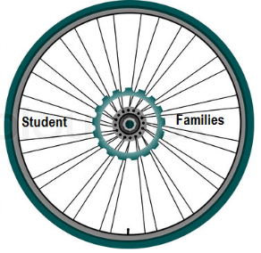

**TRANSITION PLANNING CHECKLIST FOR PARENTS**

Planning for your child’s transition to adulthood is one of the most important things you can do to pave the way to a successful future. The process can be a challenge and depending on your child’s disability, you may need to consider everything from daily living skills to employment. Realizing that your child may need a lot of support and guidance, it is also important to make sure that he/she is prepared for life after high school.

If your child has an understanding of his/her strengths, interests, and needs, this will benefit them as they enter the workforce or pursue a postsecondary education. This awareness will help him/her to understand how their disability might impact the work that they do.

Your child may also need some assistance with “soft skills.” These are the skills that people need for their jobs and for life. Having an understanding of how to ask for help, deal with conflict, and accept direction are vital in the workplace. An employer also appreciates an employee who is prompt, has good hygiene, and dresses appropriately for the workplace. Some young adults may need instruction in this area.

Below is a checklist of just some of the things that families might want to address when beginning the transition planning process.

**Employment and/or Post Secondary Education**

* Identify your child’s strengths, interests, and needs.
* When writing an education or training goal, consider all options (e.g., university, community college, vocational training, personal development classes). Contact the preferred school at least two years ahead for information on admission requirements and the availability of disability services.
* When developing an employment goal, explore community options. Vocational assessments should be done in high school. Contact Vocational Rehabilitation Service (they may become involved in the IEP Process); learn about One-Stop Career Centers and other employment assistance for people with disabilities.
* Incorporate college preparation or vocational training as a coordinated activity in IEP transition planning.
* Assemble documentation of disability with most recent evaluation results
* Explore financial aid resources
* Be aware that at the college level parents need written consent from the student to obtain access to their child’s records
* Know the difference between the laws that govern education at the secondary level (IDEA) and at the college level (ADA)
* 504 Accommodation Plans may follow an individual into college or the workplace.
* Help your child find opportunities to gain experience through work or volunteer activities. These experiences will help build your child’s resume.

**Daily Living Skills**

* Consider transportation needs, personal and/or public, with regards to all aspects of their life (e.g., shopping, medical).
* Identify your child’s understanding of managing their personal finances
* Provide your child with opportunities to practice household chores (e.g., cooking, shopping, laundry, housekeeping)
* Determine if your child needs additional instruction or support with the development of social, communication, and self-advocacy skills.
* Identify their knowledge base regarding their disability, health and medication, sexuality, and available support networks. Ensure that your child is able to obtain health care and deal with insurance
* Explore recreation and leisure options, including social outlets in the community
* Develop a plan for different types of emergencies

**The Age of Majority (18 years of age)**

* When a child turns 18, under law, their rights and responsibilities change regardless of the presence of a disability.
* Consider options well in advance if there is a need for someone to act in a decision making capacity for your child after he/she turns 18.
* Before your child turns 18, learn about various types of guardianship, conservatorship, power of attorney and other legal options.
* At age 18, students receive a Transfer of Rights notice from the school—at this point parents no longer have the right to the child’s records unless their child signs a release.
* An Individualized Education Program (IEP) ends when a child exits high school, it does not extend into post- secondary education (e.g., college, trade school).
* All males must register for the Selective Service, regardless of disability or special health care needs. Log on to their website at www.sss.gov to register online.
* Obtain a driver’s license or state ID.
* Register to vote

**Financial Planning**

* Families should be aware of how their child’s ownership of assets could affect eligibility for benefits from social security, Medicaid, and other services

**References**

* Raising Special Kids (RSK). (2010).
* *Connecting.* Vol. 15. 1-4. Phoenix, AZ: Author.www.raisingspecialkids.org PACER Center. (2005).
* *Ten tips that may help ease your child’s transition to adulthood*. Minneapolis. MN: Author. www.pacer.org

The content of this publication was developed in 2010 by the Parent Information Network (PIN) with funds allocated by the U. S. Department of Education under IDEA 2004. These contents do not necessarily represent the guideline of the agency, nor should endorsement by the federal government be assumed.

* Identify how financial support your child may receive impacts other benefits.
* Consult with a legal professional who specializes in estate planning for families of children with disabilities.Ask about trusts, education savings plans, wills and life insurance.
* Learn about Social Security—Supplemental Security Income (SSI), Social Security Disability Insurance (SSDI), community services for adults with disabilities (e.g., food stamps), and Social Security Administration work incentives: PASS, Ticket to Work, Section 1619 (a) and (b) of the SSI law, by logging onto www.ssa.gov.

**Housing**

* Learn about possibilities for independent living.
* Consider various housing options (e.g., living by oneself, finding a roommate, entering a group home, staying with family)
* Research types of group homes in the area where your child want to live, or consider beginning a co-op with other families.
* Examine funding options
* Learn about the Fair Housing Act and your young adults rights online at www.hud. gov/offices/fheo/FHLaws/index.cfm

**STUDENT TRANSITION QUESTIONNAIRE**

Student Name: ________________________________ _ Date: _________________

School: _______________________________________ _ Grade: _________________

Which of the following can you do independently (on your own)?

* Plan and prepare my meals
* Count money and use banking services
* Household management (pay bills, rent, household maintenance, cleaning, etc.)
* Schedule appointments
* Select, purchase, and care for clothing
* Use telephone
* Attend doctor’s appointments and take medication
* Visit the beauty salon/barber shop for hair cut
* Self-advocacy (find assistance in legal, medical, and financial areas)

Where do you think you will be living after you leave high school?

* By yourself
* With a friend/roommate
* With your family
* Group home
* University Dorm, Military Base

Mark the items you need more information on:

* Community agencies
* Marriage and family planning
* Substance abuse issues (drugs and alcohol)
* Death/loss
* Sexuality and safe sex
* Military recruiting
* Living Arrangements (having a place to live)
* Family Life/Social Relationships (getting along with family and friends)
* Physical/Mental Health (feeling healthy)
* Financial Security (managing your money)
* Continuing Education (learning new skills)
* Transportation (getting around town)
* Social/Civic Responsibility (being a good citizen)
* Pregnancy/prenatal care/parenthood

Do you have:

* State ID
* Social Security number and card
* Driver’s license

After high school, you would like to:

* Do nothing
* Join the military
* Unsure
* Get a full-time job
* Work part time
* Go to college or career tech

Mark the things in school that are difficult for you:

* Students
* Teachers
* Lunch time
* Attendance
* Transportation to school
* Tardiness

Do you independently get ready for school? YES NO

Do you get to school on time? YES NO

Do you have good school attendance? YES NO

Do you use a calendar or planner to organize yourself? YES NO

Mark the words that describe you best:

* a leader
* friendly
* a team player
* lazy
* quiet
* happy
* loud
* hard working
* serious
* healthy
* shy
* helpful
* patient
* strong
* honest
* talkative
* tired
* worried

Mark the following things that you need help with:

* Reading short books
* Fill in the blank questions
* Essay questions
* Paying bills and bank records
* Homework instructions
* Restaurant menus
* Newspapers and magazine articles
* Cooking directions
* True/False questions
* Spelling
* Work hours on time sheet
* Explain medical history and allergies
* Letter to a friend
* Directions to someplace
* Phone message
* Job application
* Grocery list
* Adding and Subtracting
* Multiplying and Dividing
* Measurement for cooking
* Using a calculator
* Figuring length of trips
* Reading bus schedules

Mark the chores you know how to do and you do regularly:

* Cook
* Dishes (by hand or dishwasher)
* Clean bathroom and bedroom
* Make your bed
* Take out garbage
* Wash, fold or put away clothes
* Grocery shop
* Mow the lawn, rake leaves, garden

After high school, what kinds of activities do you think you will do in your free time?

* Hang out with friends
* Watch Television
* Listen to music
* Enjoy hobbies (for example: gardening, collecting baseball cards, video games, etc.)
* Go to church or community activities
* Go to the mall or movies
* Do outdoor activities (for example: biking, hiking, fishing, etc.)

**DIPLOMA CREDIT REQUIREMENTS AND ESSENTIAL SKILLS, 2014**

|  |  |  |  |
| --- | --- | --- | --- |
| **Academic Subject** | **Regular Diploma** | **Modified Diploma** | **Extended Diploma** |
| English/Language Arts | 4 | 3 | 2 |
| Mathematics | 3 | 2 | 2 |
| *Content at Algebra I and above* |
| Science | 3 | 2 | 2 |
| *Scientific inquiry and lab experiences* |
| Social Sciences | 3 | 2[1] | 3 |
| Physical Education | 1 | 1 | 1 |
| Health | 1 | 1 | 1 |
| Second Languages/ The Arts/Career and Technical Education (CTE) | 3 | 1[2] | 1 |
| Electives | 6 | 12[3] |  |
| **TOTAL CREDITS** | **24** | **24** | **12** |
|  | | | |
| **Essential Skills** | Reading | Reading | NA |
|  | Writing | Writing | NA |
|  | Math | Math | NA |

Regarding students seeking a Modified Diploma, Section 20 of OAR 581-022-0615: Assessment of

Essential Skills clarifies that, students seeking a Modified Diploma must meet the Essential Skills requirement. As described in OAR 581-022-0610: Administration of State Tests, Modifications,

Pursuant to State and Federal Law, school districts and public charter schools may modify the achievement level, construct, or measured outcome of the OAKS or Work Sample Essential Skill assessment options for students on IEP or 504 Plans. For students NOT on IEP or 504 Plans, the modifications are limited to the Work Sample assessment options.

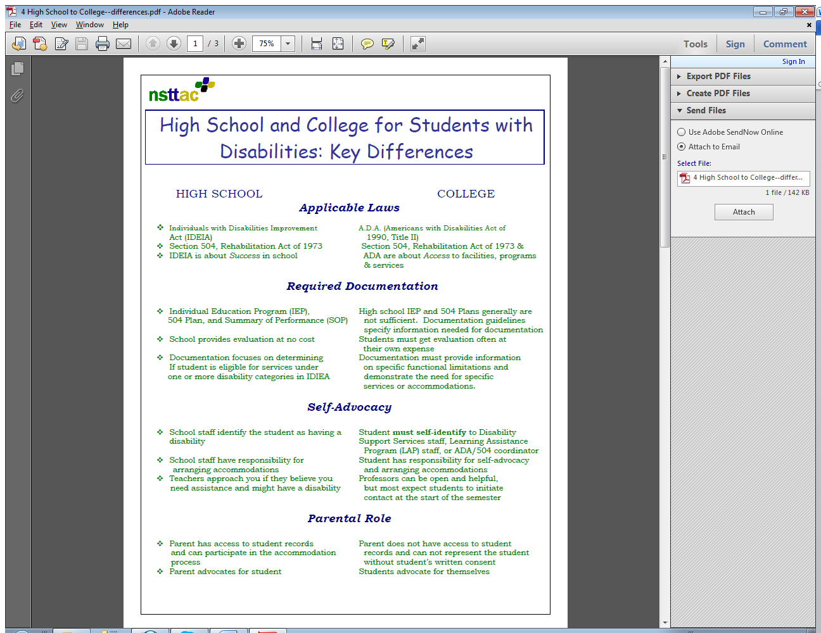

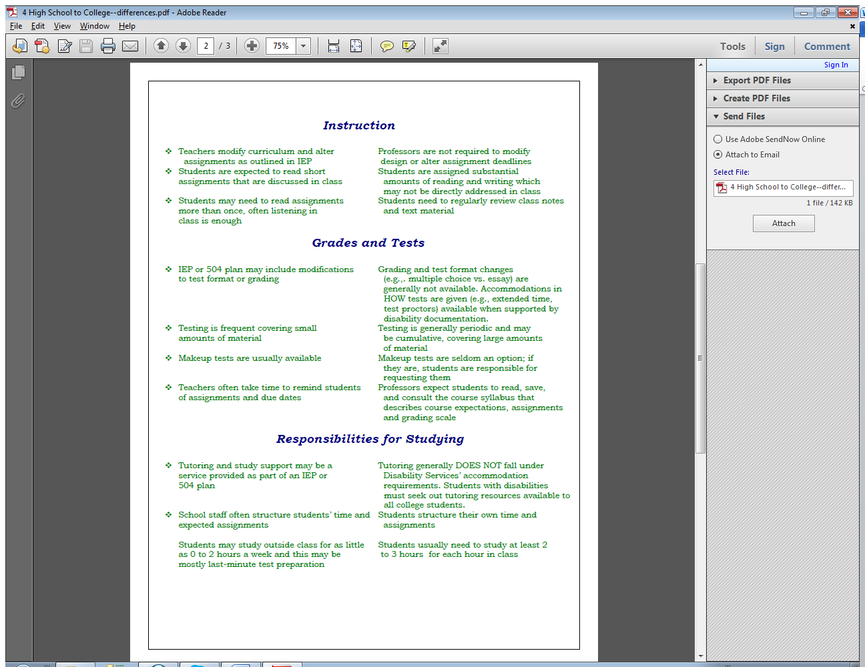

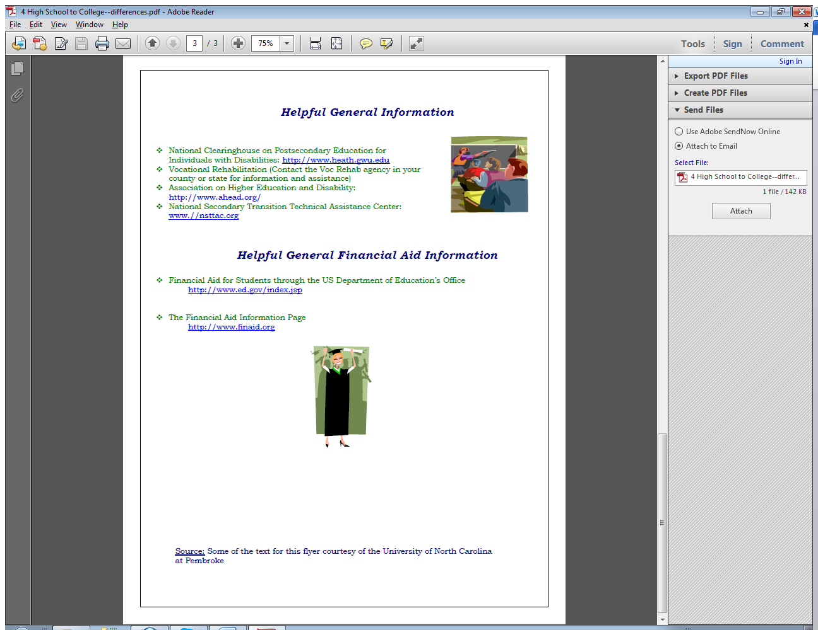

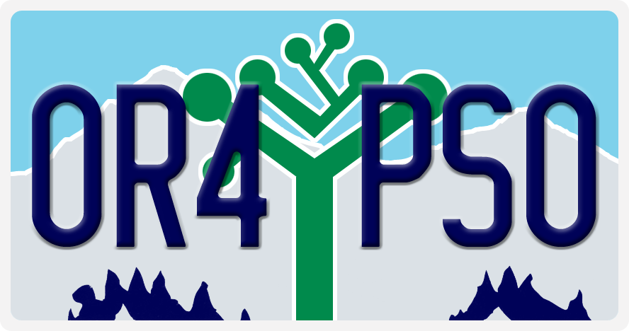

**POST SCHOOL OUTCOME (PSO) DATA COLLECTION**

**What is the PSO?**

Collecting information about the work and school activities of students after they leave special education services is federally required for all states. This information also lets school districts improve their high school transition programs based on the results of this data collection. Oregon asks the school district to conduct follow up phone interviews with former students or their families.

**What does it involve?**

* Most districts ask the students to participate in an **Exit Interview** during their last year in the school district before moving on to adult life. This interview asks about plans for the future, and collects phone numbers, social media sites, or whatever contact information the student offers to the school districts to help them find you the following year.
* In the *spring* of the year after leaving, many districts send a **reminder post card** to former students to check on the best way to reach the student or a family member for the interview.
* One year out of school, the district may call the contact numbers to reach the student or a family member. The **follow up interview** will be conducted between *June and September* in the year following the student leaving school.
* Districts will use the information that is gathered to better understand the impact of district practices on the success of their students. You input is valued, and used to help improve services for the students who follow you.

**Timing of events:**

* The Exit Interview can be any time during the final year of high school or attendance in a transition program. Adult students 18 and older and families of students under 18 must sign an agreement to participate to participate in the Exit Interview.
* Follow up interviews are conducted 12 months after you exit, sometime between **June and September**.
* A post card to notify you that the school district will be calling you to do an interview may be sent by your school district. A sample of the type of information that will be on that post card is provided on the next page.
* The interview will be conducted by phone and will take about 10 minutes. It contains questions about school or training experiences, and jobs or other work experiences in the 12 months after leaving school. A copy is included after the post card example.

**Confidentiality:**

Your information is entered online into a secure website and personally identifiable information is removed. Districts are provided with a summary report of the outcomes for their students, and the statewide results are summarized to meet the federal reporting requirements.

Example: **Post Card Notification of Post School Outcome Data Collection**

After you leave high school, you may receive a post card, like the one below,  alerting you that your high school may be calling you to ask some questions.  Please help your high school and fellow students, by taking 10 minutes to answer those questions.

|  |  |
| --- | --- |
| Inline image 1 | |
| The (insert School or district name) needs your help! We want learn from former students how we can improve high school transition services. You will receive a phone call that asks questions about what you have been doing since you left school, such as have you worked or gone to school? Answering the questions will take about 10 minutes.  Teachers will use answers from students like you to learn what they can do to help other youth get jobs and go to school after high school. To make sure you have a chance to answer the questions, please call xxx-xxx-xxxx to help the district find you or a family member who can help with this information. We want to hear from you: what you tell us is very important. Questions, contact your district or Pattie Johnson at [johnsop@wou.edu](mailto:johnsop@wou.edu) | **________________________________________________**  **________________________________________________**  **________________________________________________** |

|  |
| --- |
| **Status of telephone interview:** 🞎 Completed 🞎 Not completed 🞎 Refused 🞎 Unable to find contact info  **Person interviewed:** 🞎 Student 🞎 Family member 🞎 Other **SSID:** ________________  **Name of interviewer**: _________________________ **Number of attempts to contact**: ______  **Position:** 🞎 Teacher/specialist 🞎 Admin 🞎 YTP 🞎 Paraprof/Educ Assist 🞎 Secretary 🞎 Other: ___________ |
| **Telephone Interview - Special Education Students** |

Interviewer: suggested script has been provided for your use at <http://www.tcntransition.org/districtResources.php>

►**INTRO:** The questions cover activities related to education, jobs, and life in general. We will start with questions about school in the year since high school. **[Questions with ‘*’ are required for complete interview.]**

|  |
| --- |
| **Postsecondary School** |

*1. In the 12 months after leaving high school, did you *ever* attend any school, job training, or education program? If more than one program, use the one with the longest attendance or a completion certificate.

***\*\*\* shows you will need to skip to the question indicated***

___ Yes

___ No *\*\*\* skip to question #4*

___ Don’t know/No answer  *\*\*\* skip to question #4*

*2. Please describe the type of training program or school. *(Wait for answer, check box below, and read the option you selected, or the list of options; if it helps to be sure you marked the best choice.)*

*The* ***Follow-up Key*** *lists Oregon 2 and 4 year colleges*

___ College or University (4 year)

___ Community or Technical College (2 year)

___ Vocational Technical School—less than a 2-year program

___ Short-term education or employment training program (WIA, Job Corps, etc.)

*___* High school completion document - certificate (return to high school, Adult Basic Education, GED, etc.)

___ On a mission, AmeriCorps, in the Peace Corps, etc.

___ Other: *(Specify, but will not count for engagement)* _______________________

___ Don’t know/No answer

*3. Did you complete an entire term / semester or complete a short term program?

___ Yes

___ No

___ Don’t know/No answer

|  |
| --- |
| **Employment** |

*4. In the 12 months after leaving high school, did you *ever* work*?*

___ Yes

___ No *\*\*\* skip to question #10*

___ Don’t know/No answer *\*\*\* skip to question #10*

*5. Where is (was) the job? – . *(Wait for answer, check box below, and read the option you selected, or the list of options; if it helps to be sure you marked the best choice.)* ***If more than 1 job, answer for job they held 3 months or more, at minimum wage***

___ In a company, business, or service with people with and without disabilities

___ In the military

___ In supported employment (paid work with services and wage support to the employer)

___ Self-employed

___ In your family’s business (e.g., farm, store, fishing, ranching, catering)

___ In sheltered employment (where most workers have disabilities)

___ Employed while in jail or prison

___ Other *(Specify- but will not count for engagement) ________________________*

___ Don’t know/No answer

6a. What was the job title? _________________________________________________________________

*6b. During the 12 months after leaving high school, did you work for a total of 3 months (about 90 days)? [NOTE: Days do not need to be in a row.]

___ Yes

___ No

___ Don’t know/No answer

*7. Did you work, on average, 20 or more hours per week?

___ Yes

___ No

___ Don’t know/No answer

*8. Were you usually paid at least minimum hourly wage? **(*$9.10 for 2014 in Oregon****)*

___ Yes

___ No

___ Don’t know/No answer

9. Did you receive the same benefits as your co-workers?

___ Yes  *\*\*\* skip to question #11*

___ No *\*\*\* skip to question #11*

___ Don’t know/No answer *\*\*\* skip to question #11*

*[If student has* ***not gone to school or held any job*** *since high school]*

10. Why haven’t you worked since leaving high school? *Wait for answer, check best option from list below.)*

___ Haven’t found a job (1)

___ Medical reason (2)

___ Incarceration (3)

___ Don’t want need to (4)

___ Disability (5)

___ Baby/family (6)

___ Drugs/alcohol (7)

___ No driver’s license (8)

___ Not old enough (9)

___ Need skills/help, trying (10)

___ Other (11)

___In school (12)

___ Don’t know/No answer (99)

|  |
| --- |
| **Additional Data** |

►We’re almost done, these next questions cover additional things about your life after high school.

11. Do you have a driver’s license? *(Wait for response)*

___ Yes

___ No

___ Learner’s Permit

___ Don’t know/No answer

12. Where are you currently living?

___ Family (1)

___ Campus or military base (2)

___ Independently or with a friend (3)

___ Homeless (4)

___ Foster place, group home (5)

___ Jail (6)

___ Other (7)

___ Don’t know/No answer (99)

1. I am going to read through a list of daily living activities and ask you whether you do that activity independently now.

|  |  |
| --- | --- |
| Activity | Do you feel you can do this independently? (1) |
| a. Money management (banking, bills) | ⬜ Yes ⬜ No ⬜ Don’t know/No answer |
| b. Grocery shopping | ⬜ Yes ⬜ No ⬜ Don’t know/No answer |
| c. Housekeeping | ⬜ Yes ⬜ No ⬜ Don’t know/No answer |
| d. Meal preparation | ⬜ Yes ⬜ No ⬜ Don’t know/No answer |
| e. Transportation | ⬜ Yes ⬜ No ⬜ Don’t know/No answer |
| f. Recreation | ⬜ Yes ⬜ No ⬜ Don’t know/No answer |

1. I am going to read through a list of agencies and ask you if you have received any assistance from any of them since you left high school. You may or may not have heard about all of them.

|  |  |
| --- | --- |
| Agency | Have you received assistance? |
| 1. (SSDI) Social Security Disability Insurance   (SSI) Supplemental Security Income | ⬜ Yes ⬜ No ⬜ Don’t know/No answer |
| 1. Developmental Disabilities (brokerage service) | ⬜ Yes ⬜ No ⬜ Don’t know/No answer |
| 1. (OVRS) Office of Vocational Rehabilitation | ⬜ Yes ⬜ No ⬜ Don’t know/No answer |
| 1. (TANF) Temporary assistance for needy families | ⬜ Yes ⬜ No ⬜ Don’t know/No answer |
| 1. Oregon Trail Card – SNAP (Supplemental Nutrition Assistance Program) | ⬜ Yes ⬜ No ⬜ Don’t know/No answer |
| 1. College Disability Services at a college or   training program | ⬜ Yes ⬜ No ⬜ Don’t know/No answer |
| 1. Loans, financial aid | ⬜ Yes ⬜ No ⬜ Don’t know/No answer |

15. What type of recreation activities do you participate in? _______________________________________

_______________________________________________________________________________________

_______________________________________________________________________________________

16. If you could tell your school one thing, what would you tell them (make a suggestion to help better prepare current students for life after high school)? (*Prompt: What was most helpful or could have been done better?) [****Speak aloud as you write so student knows what is being recorded.]***

_______________________________________________________________________________________

_______________________________________________________________________________________

_______________________________________________________________________________________

_______________________________________________________________________________________

***Thank you for your help, the interview is done!***

***Interviewer:***  *Be sure and fill out the information on the first page to*

*complete the interview!*

For technical assistance or questions, contact Pattie Johnson at 503-838-8779 or Sally Simich at 503-947-5639

**ONLINE RESOURCES FOR STUDENTS AND FAMILIES**

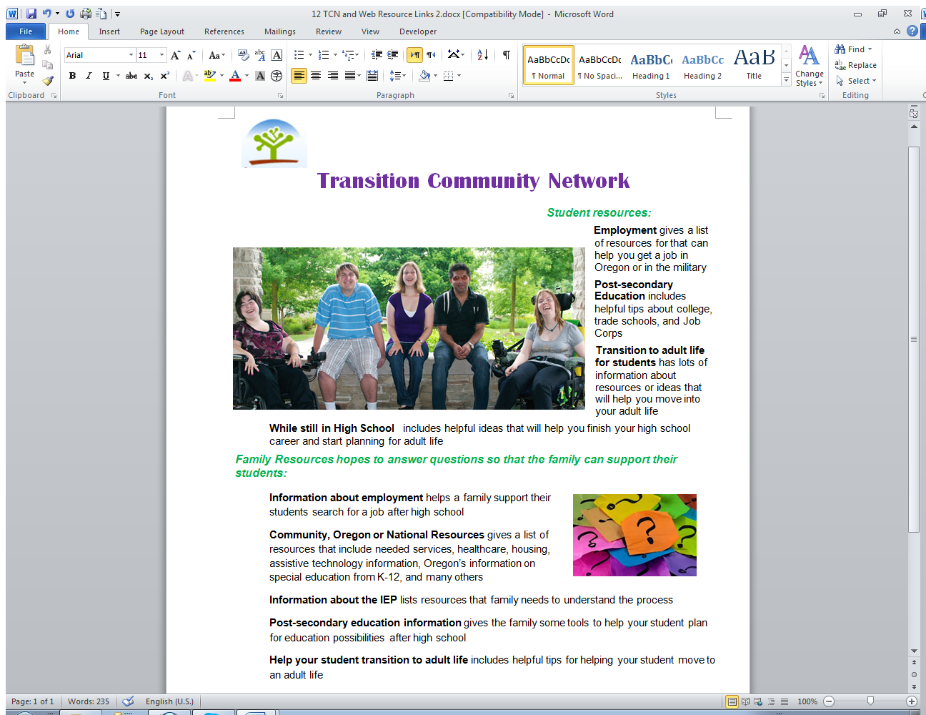Interactive websites for transition planning from NSTTAC <http://nsttac.org/content/interactive-websites-transition-planning>

**Transition Community Network** <http://tcntransition.org/> this Oregon site has resources to help find information about employment and post-secondary education. It also includes recreation resources, community & national resources, transitioning to adulthood, and resources to help while still in high school. There are sections for students and families, teachers, and school administrators.

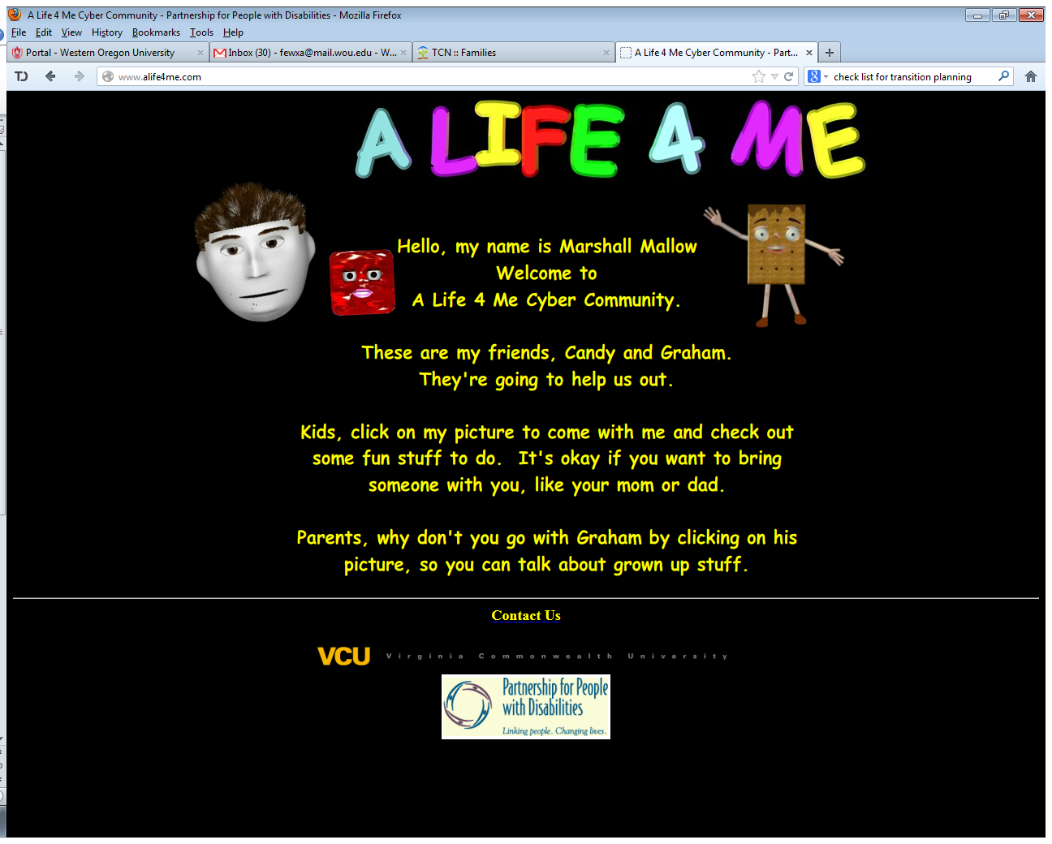**A Life 4 me** <http://www.alife4me.com/> from Virginia Commonwealth University

A Life 4 me provides information for students and parents useful in navigating the transition from school to life after school. The site allows students to match interests with jobs and gather information about volunteer or paid experiences.

**About Me!** <http://nsttac.org/content/about-me> This includes lessons developed for teaching self-awareness and self-advocacy

**I’m determined** <http://www.imdetermined.org/transition_guide/> Self-Determination is all about you taking control of your life!  Part of taking control is taking responsibility for your education, your goals and your future.  Strategies to help you do this are listed on this site.

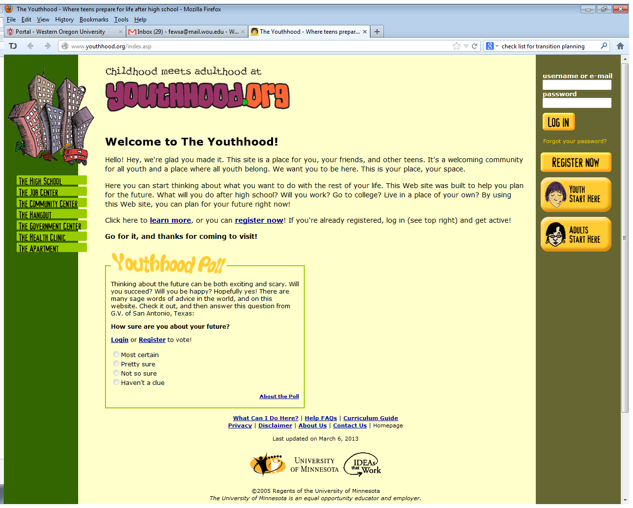**YouthHood.org** <http://www.youthhood.org/index.asp> This Web site was built to help you plan for the future. What will you do after high school? Will you work? Go to college? Live in a place of your own? By using this Web site, you can plan for your future right now!

1. **Social Sciences** may include history, civics, geography and economics (including personal finance).
2. Second Languages/The Arts/Career and Technical Education (CTE) units may be earned in any one or a combination of courses.
3. School districts and public charter schools shall be **flexible in awarding the remaining 12 units of credit**. The credits must meet the needs of the individual student as specified in the **education plan** of the student with the expectations and standards aligned to the appropriate grade level academic content standards. These credits may include: (A) Additional core credits; (B) Career and Technical Education; (C) Electives; and (D) Career development.