Indicator 14 -- Use Data to Make Effective Decisions for Transition Programs

Did you set performance goals last year?
How does your performance measure up against the previous year? Progress?
Are your students being successfully engaged in School and Work?
How does your district perform against the state Targets?

 | 2013 State
Question | Performance | Target
Have you met the state target for students enrolled in a 2 or 4 year program? | 26% | 27%
Did you meet the target for competitive employment? | 29% | 26%
Are your students working in other jobs, or learning in other training programs? | 15% | 16%
Do you have a lower percentage of students that are not engaged? | 30% | 0%

 | District size
 | Very Small | Small | Medium | Large | Total
Leavers per district | 1-4 | 5-15 | 16-50 | 51-355
Number of districts | 48 | 51 | 43 | 19 | 161
Total leavers | 112 | 431 | 1,231 | 2,329 | 4,103
Selected for interviews | 109 | 427 | 908 | 1,261 | 2,705
Number interviewed | 61 | 243 | 699 | 911 | 1914
Response rate | 56% | 57% | 77% | 75% | 72%
Engagement Rate | 80% | 71% | 72% | 67% | 70%
How do your district outcomes perform against other like-sized districts?
- Response Rate
- Engagement Rate
Pay particular attention to students who have not been engaged in school, training, or employment in the year after leaving school:
- What groups are not where they should be in education or employment?

Look at your Indicator 13 data
- Does initial compliance on the eight transition standards point to an area to improve?
Look at who is leaving with each of the diploma options
- How does that fit the Outcome results?

What programs do you have for at risk youth?
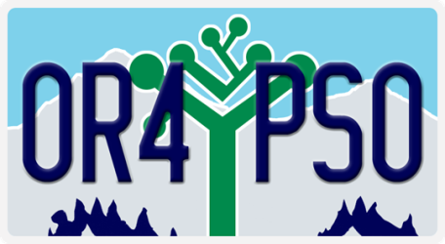
Strategies for Increasing Post School Outcome Results

Collect important information before the student leaves:

Districts who:
- Post the Logo so students learn about the collection
- talk with students during their final year in school,
- have the parent or student sign the agreement to participate in the Exit interview early in the school year
- have the student address the reminder post card before he or she leaves school
- collect contact information for finding the student (or someone who probably knows where they are) after they leave, and
- let the students know the importance of participating in the follow up interview
- and asks the student who they would like to talk to the following year about their experiences
are more likely to reach the student a year out

Send the reminder post card to the student or family before you call:
- reminds students and families of the follow up interview
- lets them know why someone from the district will be calling
- reminds them that their experiences are valuable
- easy to identify by the logo
- allows student or family member to set up a call at a convenient time

Collect the Interview Information
- students are more likely to share their experiences after leaving school with someone they know
- make calls during the day, but for hard-to-reach students or family members, you may need to try meal times, evenings, or weekends
- sound like it matters, let them know that sharing their experiences will help other students, and will help the teachers to make a difference
- have local resource information handy: this may be an opportunity to connect a former student with resources they can use to take another step
- when possible, interview the student, but a family member or acquaintance that is familiar with the former students experiences can complete the interview

The Post Card form and other resources for the Post School Outcomes collection can be found
- on the PSO 2.0 application on the ODE Resources TAB and
- on the Transition Community Network District Resource page:
http://tcntransition.org/resources/post-school-outcomes-materials/

