SECONDARY TRANSITION PROCEDURAL COMPLIANCE STANDARDS
States are required to submit the initial compliance on eight IEP standards annually. Districts are given a selected set of files to review, and report the status of each student on each of the transition standards. The following table displays the trends shown for each of the standards over the past four years.
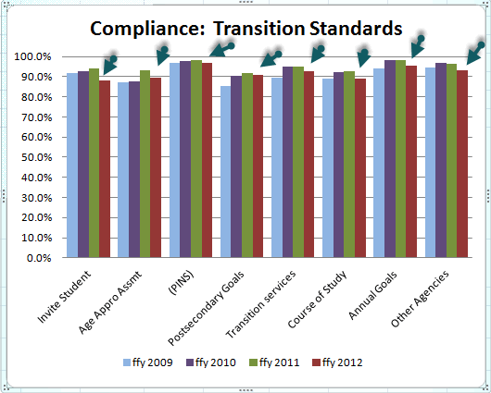
The chart shows that initial compliance has dropped for all of the eight standards in the 2012-13 school year. Inviting the student had the biggest drop (6%). Age appropriate assessment and course of study both dropped around 3.5%. Overall, the number of students with all eight standards in compliance dropped from 80% to 69%. The file could be out of compliance on only one standard, or on all eight to be considered out of compliance.
There was also a drop in the percentage of student files that were initially compliant from two years ago, falling from 81.5% to 80%

PROCEDURAL COMPLIANCE TRANSITION STANDARDS FOR A QUALITY IEP

Standard # 16: Beginning with the first IEP in effect when the student turns 16, the IEP Team Notice:
- Invited the student;
- Informed the parent and student that consideration of the postsecondary goals and transition services would be addressed; and,
- Identified any other agency that would be invited to send a representative if appropriate.
- Included the purpose, time and place of meeting, and who will attend;
- Informed the parent they may invite other individuals who have knowledge or special expertise regarding the child
- Informed the parent that the team may proceed with the meeting if the district is unable to convince the parent that they should attend. §300.322
- Informed the parent of whom to contact prior to meeting to provide information if they are unable to attend. OAR 581-015-2190
Standard # 28: For students who turn 16 when the most recent IEP is in effect or who are older than 16, the IEP contains Present Levels of Academic Achievement and Functional Performance including:
- The strengths of the student;
- The concerns of the parents for enhancing the education of their child;
- The present level of academic performance, including the student’s most recent performance on State or district-wide assessments;
- The present level of developmental and functional performance (including the results of the initial or most recent evaluation);
- How the student’s disability affects involvement and progress in the general education curriculum. §300.320
- The student’s preferences, needs, interests; and
- The results of age-appropriate transition assessments §300.324.
Standard # 22: For students who turn 16 when the most recent IEP is in effect or who are older than 16, the most recent IEP meeting also included the student; or, if the student did not attend, other steps were taken to ensure that their preferences, interests and needs were considered as part of the IEP development; §300.321 §300.322
Standard # 36: For students who turn 16 when the most recent IEP is in effect or who are older than 16, the IEP includes appropriate measurable postsecondary goals based upon age-appropriate transition assessments related to training, education, employment and, where appropriate, independent living skills. §300.320
Standard # 37: For students who turn 16 when the most recent IEP is in effect or who are older than 16 the IEP includes transition services needed to assist the student in reaching the post secondary goals. §300.320
Standard # 38: For students who turn 16 when the most recent IEP is in effect or who are older than 16 the IEP includes courses of study needed to assist the student in reaching the post secondary goals. §300.320
Standard # 34: For students who turn 16 when the most recent IEP is in effect or who are older than 16, the IEP contains a statement of measurable annual goals including academic & functional goals. §300.320
Standard # 23: For transition age students, the most recent IEP meeting also included, to the extent appropriate, and with the consent of the parent or adult student, a representative of any participating agency that was likely to be responsible for providing or paying for transition services. §300.321

