FACT is Oregon’s Parent Training and Information Center on Issues Related to Special Education!
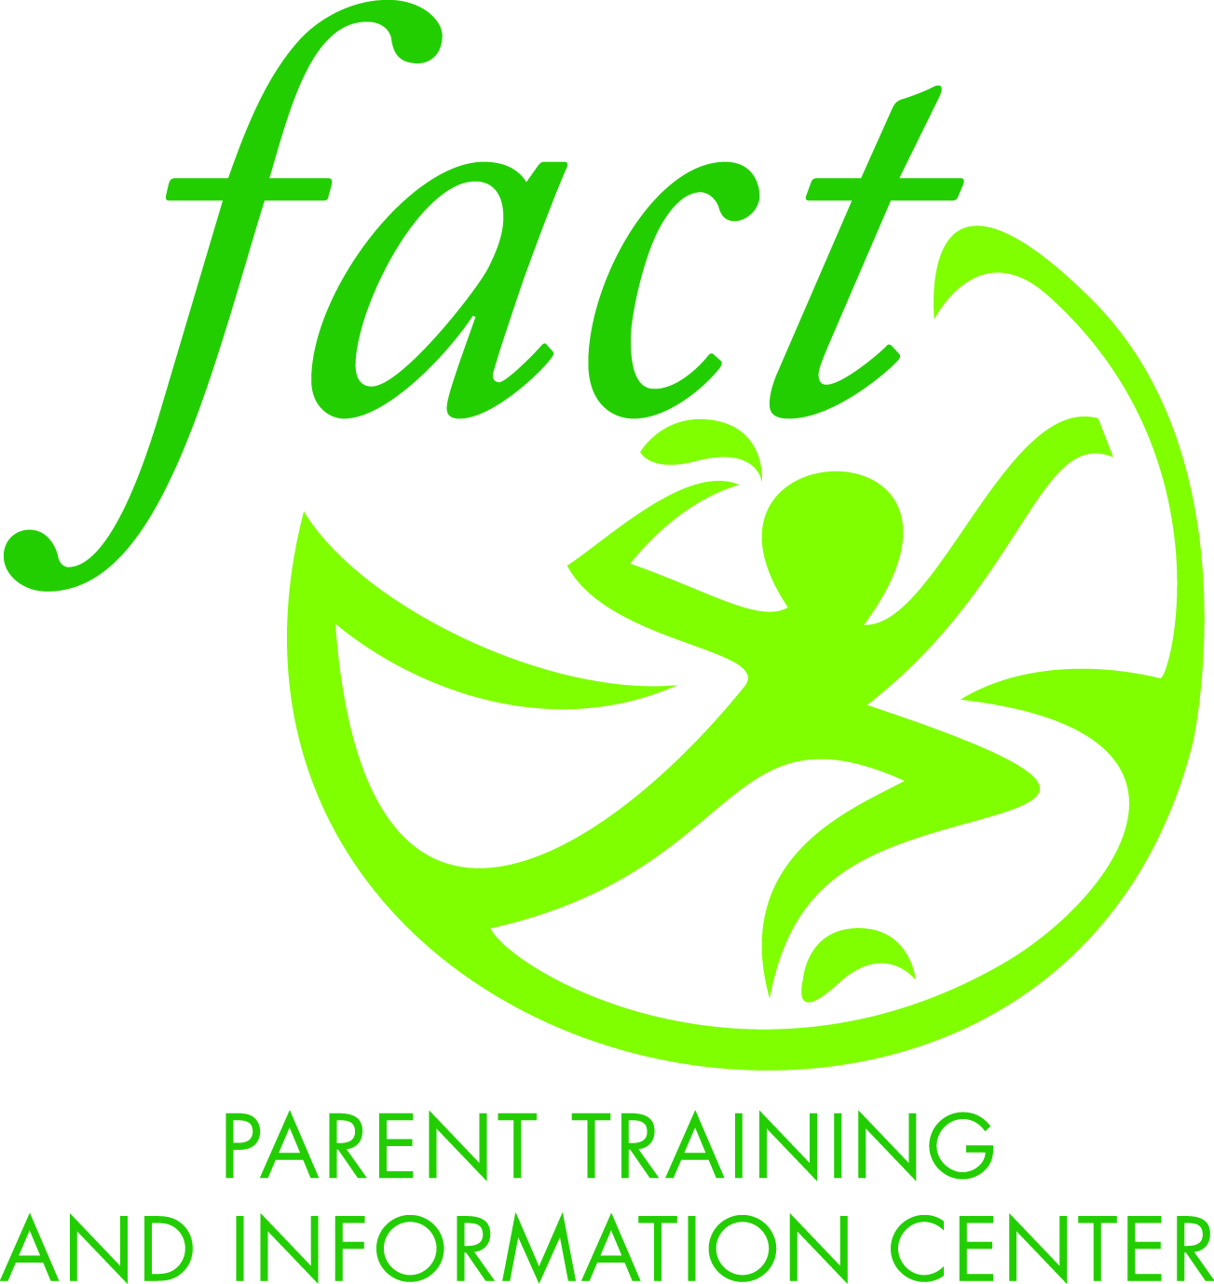
Formed in 2002, FACT has grown over the last decade to successfully empower Oregon families experiencing disability. Using a parent-to-parent model, FACT provides training, IEP support, and parent-to-parent connections that promote the understanding that disability is a natural part of the human experience.
In September 2012, the U.S. Department of Education, Office of Special Education Programs awarded FACT the designation of becoming Oregon’s Parent Training and Information Center [PTI]. FACT has also been awarded the Oregon Department of Education state PTI contract.
FACT’s services are framed by the following principles:
- A firm belief that disability is natural
- The importance of using person-first language
- The importance of the dignity of risk
- Presuming competence of a person experiencing disability
- Having a vision for life after school
- Advocating that all people should be able to access and be welcomed by their communities

Using a collaborative approach, FACT has partnered with dozens of organizations, school districts, agencies, and local resources to build community support for families experiencing disability. Its services include the following:
- FACT PTI: provides information, training, resources, and support to parents whose children experience disability and/or special learning needs, and to youth entering into adulthood.

- FACT Family Network: provides peer-delivered support, information, resources, referral assistance, family-to-family networking, and training opportunities.

- The Family Advocacy Network: creates opportunities statewide for family leadership development, family empowerment to effect system change, education reform, policy decisions, and participation in advocacy and grassroots systems change movements.

- Parent2Parent: offers statewide, parent-to-parent connections for families experiencing disability, including specially trained mentors able to support families in preparation and planning for their child’s IEP.

- FACT Person-centered Planning: a pilot program that provides strengths-based, person-centered plan facilitation to families, school districts, and other agencies.

To learn more about FACT, please visit the website http://factoregon.org/parent-training-iep-education/

