Transition Community Network

Student resources:
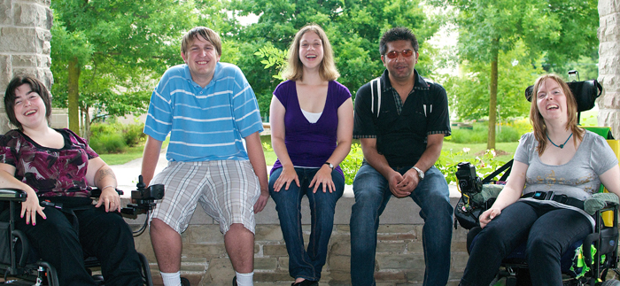
Employment gives a list of resources for that can help you get a job in Oregon or in the military
Post-secondary Education includes helpful tips about college, trade schools, and Job Corps
Transition to adult life for students has lots of information about resources or ideas that will help you move into your adult life
While still in High School includes helpful ideas that will help you finish your high school career and start planning for adult life

Family Resources hopes to answer questions so that the family can support their students:

Information about employment helps a family support their students search for a job after high school
Community, Oregon or National Resources gives a list of resources that include needed services, healthcare, housing, assistive technology information, Oregon’s information on special education from K-12, and many others
Information about the IEP lists resources that family needs to understand the process
Post-secondary education information gives the family some tools to help your student plan for education possibilities after high school
Help your student transition to adult life includes helpful tips for helping your student move to an adult life
While your student is still in High School helps the family understand the Oregon high school exit options, the Transition IEP process and other need information that is needed to support your student

An updated website www.tcntransition.org will open September 30, 2013

