POST SCHOOL OUTCOME (PSO) DATA COLLECTION
What is the PSO?
The collection of outcome data on IEP students leaving district services one year after exit is federally required for all states. Districts are expected to use the PSO interview results to inform decisions about transition programs, replacing ineffective practices with changes to improve outcomes for students.
Access:
Your district data security administrator will provide access to the Post School Outcomes 2.0 Application on the secure district site.
What’s required?
- Districts must provide agency contact information for those responsible for the collection, interviewers, and educators working with secondary transition students.
- Interviewing the students slated for a follow up interview or a family member one year after exiting district special education services.
- The optional Exit interviews (done before the student leaves services) is not federally required, but ODE recommends districts use the Exit interview to gather school experiences for comparison with one year out, and contact information on the student, families, and friends to increase the options for finding the student for the required follow up interview.
Timeline:
- Exit interviews and student contact information can be completed January through September.
- The list of follow up students to be interviewed is available in April.
- Follow up interviews can be conducted 12 months after the student exits, and data entry is open June through September.
- You can either enter the interviews directly online as you talk with the student, or enter the data after interviews have been recorded on paper copies.
What can we do to complete this collection and makes it useful?
- Prepare Students and families for the Interview: Inform current students about the interview process and vocabulary of the interview. Introduce the Post School Outcomes collection at the transition IEP meetings when you ask parents to sign the agreement to participate form for their students. Collect the contact information at IEP meetings.

- Encourage Students to Respond: Use strategies from NPSO’s Contacting Hard-to-Find documents to motivate students to participate in the post-school interview.
http://www.psocenter.org/content_page_assets/content_page_8/Hard%20to%20Find_Final_02_04_13.pdf
- Encourage teachers who have worked with the students to make the calls – students report greater interest in completing the interview if they know who wants the information.

- Know your Data: Review your district post-school outcome data to identify which groups of former students are having positive post-school outcomes.

- Share the Information: Talk with district special education teachers, staff, administrators, parents, and students about the post-school outcomes data of former students.

- Incorporate Evidence-Based Practices and Predictors of Post-School Success: Incorporate evidence-based practices and predictors into instruction and transition programs for students. http://www.nsttac.org/sites/default/files/assets/pdf/pdf/ebps/In-schoolPredictorsPSO_Jan2013.pdf
Directions: Special Education Post School Outcomes Application 2.0
The PSO 2.0 Application is to be used for all Post School Outcomes data entry and viewing reports
- 2014 Exit Interviews can be entered March through September.
- The list of students to interview for the 2014 Follow-Up Interviews will be posted in early April. Data can be entered June 1 through September.
Landing page: Welcome to the PSO Web Application 2.0
We need to know who to contact for notifications and questions. Enter at least one contact person in the Agency Contact section at the bottom of the page – you can specify different people for the Exit and the Follow up contacts, interviewers, and transition teachers or specialists in your district. This list will be used to notify district personnel of trainings, or updates on the PSO collection.

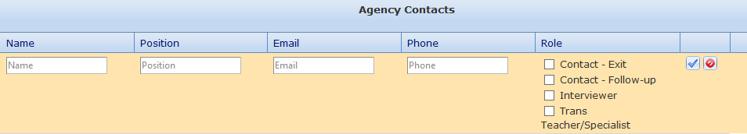
Data Entry and Reporting
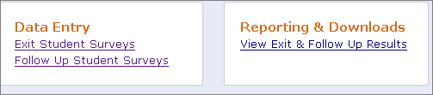
- Select which collection you want to enter by clicking one of the links in the Data Entry option.
- The Reporting & Download option takes you to Excel data downloads and reports.
- The ODE Resources tab at the top of the page contains Exit and Follow Up forms and materials.
Data Entry: Exit Interview: Student List
- Districts need to enter students that leave SE services during the school year, this cannot be pre-populated.
- Click Add New Student, and enter the SSID number and the Find button. Data on student should appear.
- Click Confirm to enter the student, their name will appear in your list, and can be clicked to enter interview.
- Information is saved when you move down to the next question. Click Submit Final when done. (You can return to edit the information by selecting Unlock Survey from the blue Action box at the end of the row.
- When you have completed all data entry for the Exit collection, check the Yes button in the peach ‘Collection Complete’ box.
- If the SSID number does not work to access a student, contact Pattie Johnson at johnsop@wou.edu as the student may be in the system for another district.
Data Entry: Follow up Interview: Student List
- Districts are provided with a list of all students who were reported as exited on the SE exit collection and did not return to be included in the following year SECC.
- Students have a Priority Code designating whether they are Required, serve as an Alternate, or have not been selected but could be interviewed.
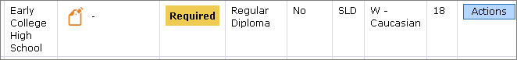
- Call logs are available which include contact information for the student, and tracking for interview attempts. Click blue Actions box to print a call log, print a survey, or unlock a record if it has been submitted as ‘final’
- You can print a collection of call logs by checking the box before the name and Downloading Call Log PDF’s from the option above the student list header. You can also download a copy of your data in Excel.
- Click on student name to open the follow up interview form for data entry.
- The survey questions will not open unless you have selected Completed or in process for the 1st question
- Information is saved when you move down to the next question. Click Submit Final when finished.
- When you have completed all data entry for the Follow up collection, check the Yes button in the peach ‘Collection Complete’ box. Notification will be sent to ODE, and you are done.
Follow up interview data notes:
- Skip patterns are built into the follow up interview form: some follow up questions will only appear after a 'yes' answer has been entered in a question.
- Questions marked with an “*” are required for federal reporting.
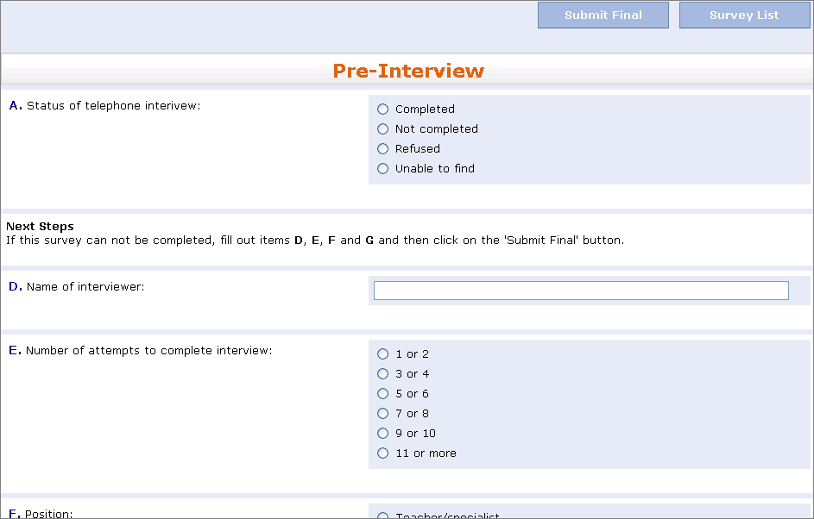
- The Pre-interview information is on the top of the call log.
- To exit after starting an interview, but before you are ready to submit final, use the Survey List button. DO NOT use the back button or the Home selection from the top bar or data may be lost
- A survey is considered completed when no additional efforts can be made to gain more information: data entered, client refused, or district unable to find the student despite making multiple attempts, preferably at different times of day or weekend.
- Completed or in process interviews include forms still in process such as appointment made to complete interview.
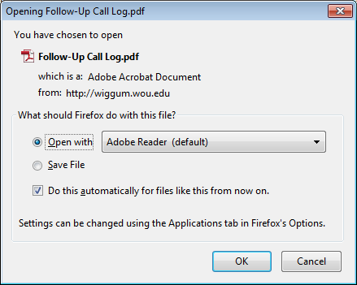
Download Call Log PDF
- To print the call log(s) select as many students as needed (check boxes in front of name)
- Use “Download Call Log PDF” to get PDF file of all selected students. This will open a window, see below (Firefox was used to open this window; it may look different using a different internet explorer).
- If additional call logs are needed later: un-select the check boxes of the students whose call logs have already been printed and select the next student or group of students
- An example of the call log is shown here; the downloaded version contains student’s information.
Other things to know
- Interviews conducted during the summer or fall should only include work or school in the 12 months after leaving school
- Students who appear on your district list as “required” need to be contacted for the follow-up survey, even if they did not participate in the Exit interview last year. Use district discretion if there are individuals that shouldn’t be contacted, but leave a note in the Question G text box explaining the situation.
- Question A – Status of interview is used to show the completion rate in the white box on the Data Entry page.
  - Completed or in process = all required questions are answered or you are ready to do online interview
  - Not completed = made contact with student/family (i.e. phone number worked, left message, started but did not complete interview, person set time to call back for interview, but never able to reach again, etc. )
  - Refused = family or student contacted, but did not choose to complete interview (make note in Question G text box describing situation)
  - Unable to find = all alternatives for finding the student or family failed (phone, emergency contacts while in school, social media, etc.)
- Please do not enter hard returns in text box comments, they all have to be manually removed later
If you have questions, please contact Pattie Johnson: johnsop@wou.edu

WHAT DO THE POST SCHOOL OUTCOME (PSO) DATA TELL US?

Districts Meeting the state Engagement Targets for higher education, competitive employment, and other school/training or work:
Assumptions and Implications
Graduation
- The majority of students leaves with a regular or modified diploma, or receive a GED which enables them to successfully attend a 2 or 4 yr university or college.
- Students are prepared to be hired in a stable, well paying job because they have the right diploma, skills to interview, course preparation, and knowledge to be hired.

Transition Standards
- The number of special education students attending a college or training program or working have most likely successfully completed their IEP. They were able to graduate from high school with a regular diploma, modified diploma with accommodations or modifications or a GED to put them on level ground with their nondisabled peers
- Based on Age Appropriate Transition Assessment, the IEP Team determined the Post Secondary Goal was a particular educational program or employment option, and the annual goals were completed which would assist the student in determining entrance criteria to the college or work -seeking strategies to enter the competitive workplace.
- The district has provided appropriate course of study, transition services and annual goals that support the students wanting to go directly into higher education or competitive employment.
- The appropriate agencies such as VR, Brokerages, SSI/SSDI have been partners in the high school transition process so that students are ready to receive services from these agencies immediately (within one year) of graduating high school.
Dropout
- The dropout rate for the district is low, with in-school supports for at-risk students

Districts Not Meeting the state Engagement Targets for higher education, competitive employment, and other school/training or work:
Considerations:

Graduation
If the number of students in a district graduating with a regular diploma was low, many capable students may be denied entrance into a 2-4 year college and thus eliminating many careers that require a higher education degree:
- Are we pushing students to get the regular diploma even if it requires more time?
- Do we have a disproportionate number of one race/ethnic group who are not getting a regular diploma?
- Have we determined which students should get a regular diploma based on the student’s disability?
- Are there some disabilities that our district does not think are able to get regular diplomas based on stereotypes?

If the district has not met the targets for competitive employment, then perhaps the district should look at local employment criteria and see if their students are receiving the most appropriate completion document and skills training that would enable their students to compete for the jobs of their choice.
- Are we “in-tune” with the needs of the local job market?
- Have we talked to business leaders about their needs?
- Have we analyzed the market for future jobs (5 yrs +) so that we are ready to guide our freshmen in the right direction (Ex. Student wants to be a journalist….do we have him visit the newspaper office or should we teach him to write a blog?
Generally, the lower paying jobs, often without benefits, can be obtained without a regular or modified diploma or GED. So if the district is not meeting the employment targets then they should re-evaluate the “focused training” they give to students (i.e., the extra time, extra help, focused teaching in specific areas, and enhanced “soft skills” (executive skills, resume writing, interviewing techniques, people skills etc) so that each student can reach the highest level of diploma possible.
- Do we have classes on communication that includes how to talk to employers?
- Do we have mentors, after-school programs, or tutors who will help with “soft skills”?

Transition Standards
If the district does not meet the target for education or employment, then the district should consider:
- Do we successfully provide the students with skills to determine and meet long-term goals?
- Did we “flush out” some of the problems associated with attending a 2-4 yr college (i.e. financial aid, housing, transportation, major, etc.)?
- Did the post secondary goals set for the student meet the student preferences, interests, needs and strengths and go beyond the education and training required for each competitive job?

The district should consider if they provide the transition services that would allow the student to determine that a 2-4 yr school was necessary or possible in order to achieve the student’s goals in life?
- Have we given adequate preparation to students so that they can make an informed decision as to what they want to do when they get out of school?
- Have we made the transition activities relative to the student and what their PINS indicate?
- Have we given adequate time to learn “soft skills”?
- Have we allowed the students to explore all opportunities in their area of interest?
- Have we made the skills we teach relevant to the times? (Based on the student’s time, not the teachers time—and based on technology that is current and up to date with what the student commonly uses at home)

Dropout
The DO number was high, thus denying or delaying many students from entering 2-4 yr college and/or the workforce, thus eliminating many careers that require a higher education degree.
- Are we identifying at-risk students early?
- Do we have specific ethnicities or disabilities that have a higher level of dropout rates?
- Have we calculated the number of dropouts that do not go on to higher education or who cannot find competitive employment?
- Have we compared that with the number of dropouts who are unemployed and for how long?

Being a dropout from high school carries a negative connotation with it, especially if you are applying for a job. It implies that you do not complete tasks that you take on. If a district does not meet the target for DO then the school district should investigate why students are “giving up”. The districts should analyze why students are dropping out and focus their efforts on effective practices that would keep students in school.
- Why don’t our student’s complete their education? Do we identify at risk students early?
- Are we honest with students about the prospects of dropping out of school and the negative connotations that it holds?
- Do we know WHY our students are dropping out?? Too hard? Too easy? Not relevant? Boring? No goals? Drugs? Alcohol?
- Are we tapping into the community to help with some of the dropout problems?

