**What is the Transition Technical Assistance Network?**

The **Transition Technical Assistance Network** is a newly developed team to support the work of Governor’s Executive order 13-04 and Employment First at both the state and local level. The network includes the Secondary Transition Liaison and Transition Network Facilitators. The Transition Network Facilitators are 8 part-time staff assigned around the state to provide outreach, technical assistance, and training opportunities for school districts in their assigned region. Please see the map for the region assignments and contact information.

Some of the goals of the transition technical assistance network include:

* Help school districts recognize and understand the outcomes of the Executive Order
* Offer technical assistance to educators for students with disabilities who are of transition age.
* Establish relationships with community partners such as Vocational Rehabilitation, Developmental Disabilities, County Mental Health, family advocacy programs, etc.
* Implement training and professional development for educators on policy and systems change.

For more information about the Transition Technical Assistance Network or for Executive Order and Employment First transition related information: <http://www.ode.state.or.us/search/page/?id=4250>

**Secondary Transition Liaison**

To support the goals of the Executive Order and the Employment First Initiative, ODE hired Heather Lindsey as the Secondary Transition Liaison. In this role, Heather will provide statewide management in the area of special education transition services as directed in by the Executive Order. She, as a part of the Transition Technical Assistance Network provides technical assistance to assist schools, districts, parent organizations, and participating agencies to support a solid understanding of secondary special education and transition regulations, and implement evidence-based transition services.

Contact information: Heather Lindsey, 503-947-5791, [Heather.lindsey@state.or.us](mailto:Heather.lindsey@state.or.us)

The **Transition Network Facilitators** will reach out to schools that work with students who are of transition age (16-21) and plan to offer assistance in training needs, sharing resources, and providing updates on any policy changes from all partnering agencies. Contact information is provided with the map.

**Overview Educator Institute Training**

The Educator Institute on Networking and Transition is full day training designed especially for middle and high school special education teachers to learn more about adult service agencies and effective strategies to assist students with disabilities in the transition process.  Topic sessions of this training includes an introduction to Vocational Rehabilitation, introduction to Developmental Disability Services, Benefits Planning Resources, sample curriculum, local Employment First Groups, Family Advocacy Groups and training opportunities for families. This was an exciting opportunity for networking with agencies within their regions.  For links to presentations from previous Educator Institute: <http://www.ode.state.or.us/search/page/?=4194>

**What’s next?**

The Educator Institute on Networking and Transition plans to carry out three more additional trainings this fall.

October 10th – Hood River October 22nd- Douglas County November 19th- Harney County

For more information, or to register please go to:

<http://www.ode.state.or.us/news/announcements/announcement.aspx?ID=9791>

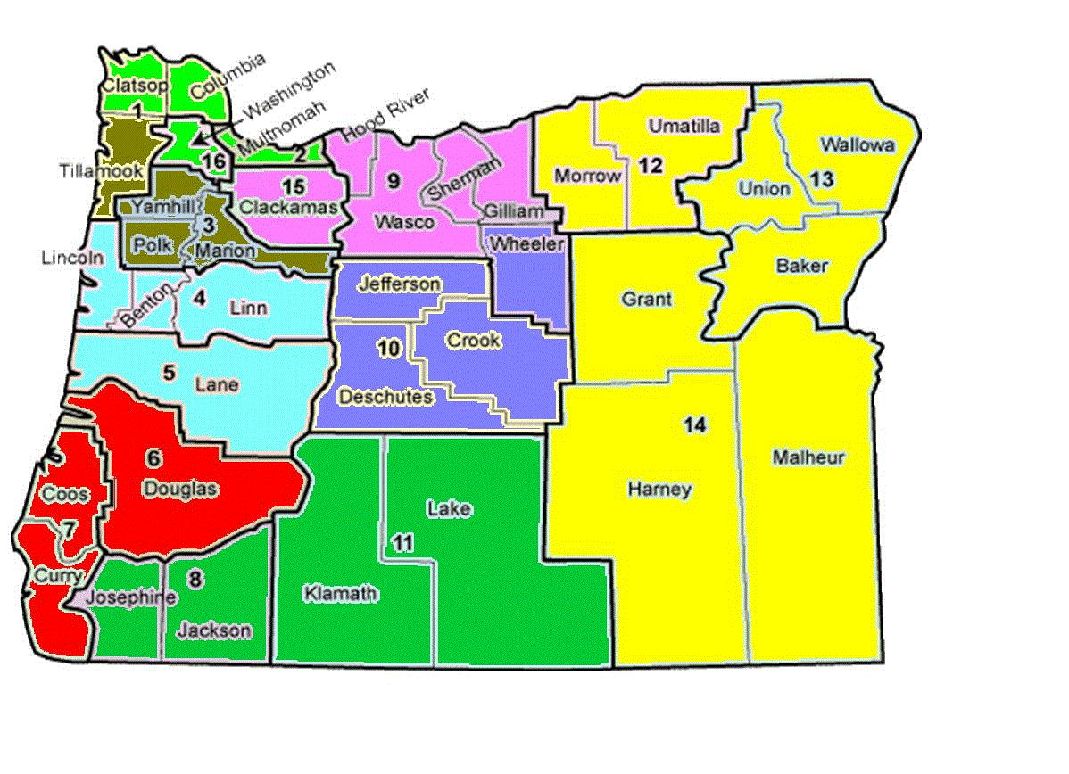**Transition Network Facilitator Regions (County Assignments)**

**Region 1**- *Portland, Washington, Clatsop, Columbia*

Lizze Juaniza- Robbie Spencer

[ejuaniza@mesd.k12.or.us](mailto:ejuaniza@mesd.k12.or.us) [rspencer@mesd.k12.or.us](mailto:rspencer@mesd.k12.or.us)

Multnomah ESD Multnomah ESD

503-257-1657 503-257-1727

**Region 2**- *Tillamook, Yamhill, Polk, Marion*

Eivind-Erik Sorensen

Willamette ESD

[Eivind.sorensen@wesd.org](mailto:Eivind.sorensen@wesd.org)

503-474-6915

**Region 3**- Lane, Lincoln, Linn, Benton

Vikki Mahaffy

Linn-Benton ESD

[vikki.mahaffy@lblesd.k12.or.us](mailto:vikki.mahaffy@lblesd.k12.or.us)

541-812-2737

**Region 4**- *Douglas, Coos, Curry*

Rebekah Mathweg

Douglas ESD

[Rebekah.mathweg@douglasesd.k12.or.us](mailto:Rebekah.mathweg@douglasesd.k12.or.us)

541-440-4777

541-440-4777

**Region 5**- *Josephine, Jackson, Klamath, Lake*

Gwyn Lema

Southern Oregon ESD

[Gwyn_lema@soesd.k12.or.us](mailto:Gwyn_lema@soesd.k12.or.us)

541-944-2418

**Region 6-** *Clackamas, Wasco, Hood River, Sherman, Gilliam*

Ariel Nielsen

[anielsen@clackesd.k12.or.us](mailto:anielsen@clackesd.k12.or.us)

Clackamas ESD

503-675-4163

**Region 7**- *Jefferson, Deschutes, Crook, Wheeler*

Marguerite (Margie) Blackmore

High Desert ESD

[Marguerite.blackmore@hdesd.org](mailto:Marguerite.blackmore@hdesd.org)

541-693-5717

**Region 8**- *Morrow, Umatilla, Union, Wallowa, Baker,*

*Grant, Harney, Malheur*

Lon Thornburg

Intermountain ESD

[Lon.thornburg@imesd.k12.or.us](mailto:Lon.thornburg@imesd.k12.or.us)

541-966-3162

TNF-1

TNF-6

TNF-4

TNF-7

TNF-5

TNF-3

TNF-2

TNF-8

