What Is Smarter Balanced?

What is CCSS Assessment?
  - Oregon’s statewide assessment (the Smarter Balanced Assessment) for English Language Arts and Mathematics is aligned to the Common Core State Standards (CCSS).

Who will take the Smarter Balanced Assessments?
  - All students in grades 3-8 & high school are expected to participate in the Smarter Balanced Assessments.

What are accessibility supports?
  - Accessibility supports are intended to reduce or even eliminate the effects of a student’s learning challenges during instruction and on the results of assessments. Implemented appropriately, these supports should not reduce learning expectations, nor should they give a student an unfair advantage over his or her classmates. Use of these supports during administration of an Oregon statewide assessment is based on individual student need and should not impact the validity of the assessment results. Since students will have previous experiences with those supports selected for use on statewide assessments, many of the same supports are typically used during instruction.

What is a Smarter – OAKS Accessibility Crosswalk?
  - The Smarter – OAKS Accessibility Crosswalk is intended to identify the changes as well as what has remained the same in terms of supports available to students participating in the statewide assessments in prior years with those available for students participating in the current Smarter Balanced Assessments.

What are the accessibility supports for modification tables?
  - A modification is any practice or procedure that compromises the intent of the assessment through a change in the learning expectations, construct, or content that is to be measured, grade-level standard, or measured outcome of the assessment that is not authorized explicitly by the Oregon Accessibility Panel and listed in the state’s Oregon Accessibility Manual(OAM). Any change away from a standard administration that is not listed in the OAM is considered a modification.
  - Assessments taken under any modified condition are counted as non-participants in all state and federal accountability measures and reports. The Modifications Tables located at http://www.ode.state.or.us/search/page/?id=540 provide examples of situations in which student testing does not provide comparable outcomes and therefore students are counted as non-participants for accountability purposes; this is not a complete or exhaustive list. Changes may occur in the Modifications Table based on review by the Oregon Accessibility Panel.

Who should I contact in my district to understand the implementation of SMARTER BALANCED?
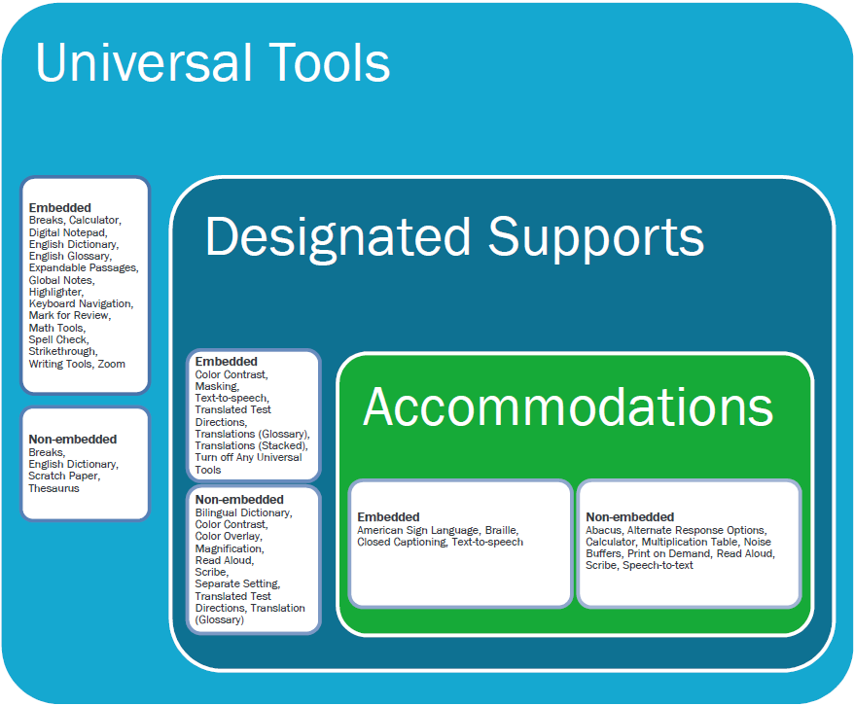
  - Contact your district test coordinator for additional information regarding the implementation of Smarter Balanced Assessments in your district.

Does each School District have a coordinator for SMARTER BALANCED?
  - Yes, your district test coordinator.

What is required for Essential Skills?
  - Essential Skills requirements can be found at http://www.ode.state.or.us/search/page/?id=2042

Would you list all accommodations needed for testing on IEP pages?
  - Yes. Consult the following 2014-15 Oregon Statewide Assessments: Guidance for Documenting Accommodations on IEPs at http://www.ode.state.or.us/search/page/?id=487 for additional information.

Assessments (ELA & Math) and Essential Skills Information and Resources
Oregon, with the other Governing States and Smarter Balanced staff, are implementing the summative, interim, and formative assessment for mathematics and English language arts beginning in the 2014-2015 school year. Additional information and resources to support teachers and students in the implementation of this assessment can be found at the following:
- Statewide Assessment Reference Pages at http://www.ode.state.or.us/search/results/?id=169
- For additional information contact your Regional Assessment Support Partners. http://www.ode.state.or.us/wma/teachlearn/testing/oaks/esdpartners1314.pdf
- Common Core State Standards--Assessment http://www.ode.state.or.us/search/page/?id=3298
- For additional information contact Kathleen Vanderwall at Kathleen.vanderwall@state.or.us
- Statewide Assessment Accessibility Supports (formerly Accommodations Manual) at http://www.ode.state.or.us/search/page/?id=487

Statewide Assessment Accessibility Supports
In Oregon, the statewide assessment accessibility supports (formerly the Accommodations Tables) are available to all students—although the decision to apply them must be based on an evaluation of individual student need. There are accessibility supports tables for the Smarter Balanced assessments (i.e., ELA and Mathematics), OAKS (Science and Social Sciences), Extended assessment, Kindergarten assessment, and the English Language Proficiency (ELPA) assessment. These tables explain and regulate the allowable supports for all students during the administration of assessments.
NOTE: If you would like to recommend instructional strategies to be included in the accessibility supports and/or modifications tables for the statewide assessments or Work Samples, please see Appendix E of the Oregon Accessibility Manual at http://www.ode.state.or.us/search/page/?id=487 For additional information contact Brad Lenhardt at Brad.Lenhardt@state.or.us

Work Samples
Work Samples are a representative sample of individual student work (e.g., research paper, science experiment, speaking presentation) that is scored using an official state scoring guide for Writing, Speaking, Mathematics Problem Solving, Scientific Inquiry, and optional Social Science Analysis at each school. Work Samples are administered in grades 3-8 and at High School.

Essential Skills
The Essential Skills are cross-disciplinary skills necessary for success in college and career. Essential Skills are a part of the Oregon Diploma and articulate the skills that all students should have at the end of high school; the skills that students are building through their school experiences starting in kindergarten.
Essential Skills information can be found at http://www.ode.state.or.us/search/page/?id=2042
For additional information contact Derek Brown at Derek.Brown@state.or.us

Alternate (“Extended”) Assessment
Oregon is planning to administer the Extended Assessment for 2014-15 the same as in prior years. However, with the creation of the Common Core State Standards, the Oregon Department of Education has developed a process (approved by the State Board) for evaluating and identifying an alternate assessment based on alternate achievement standards linked to the CCSS. This process can be found at http://www.ode.state.or.us/search/results/?id=178

